DIS-Points- MacCorkle-Kentucky

A nice example of an Early Archaic MacCorkle found in Kentucky. Very thin with nice workmanship and form. In good condition with no modern damage. X - Davis. Measures 1 13/16" x 1 5/8".

# Thin Kentucky Boyle Chert MacCorkle X - Davis AACA

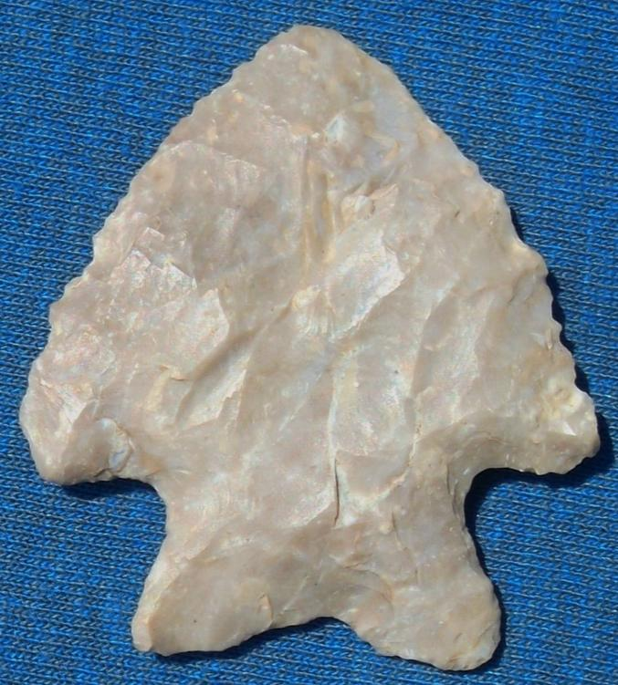

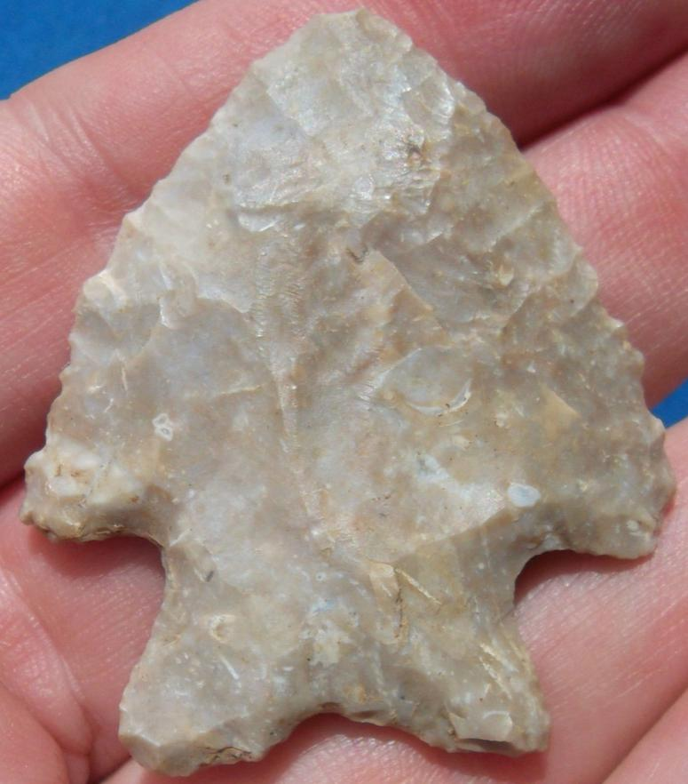 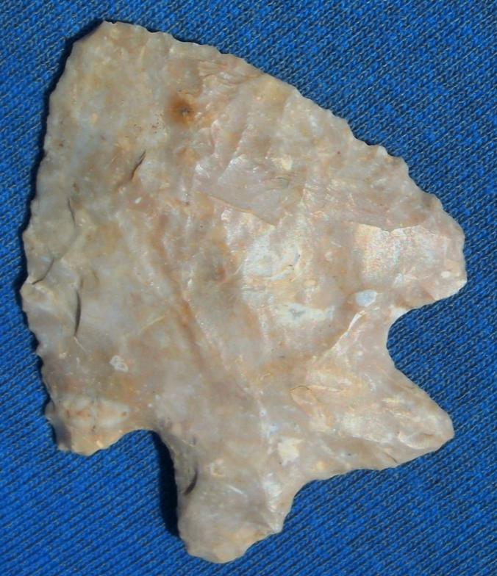 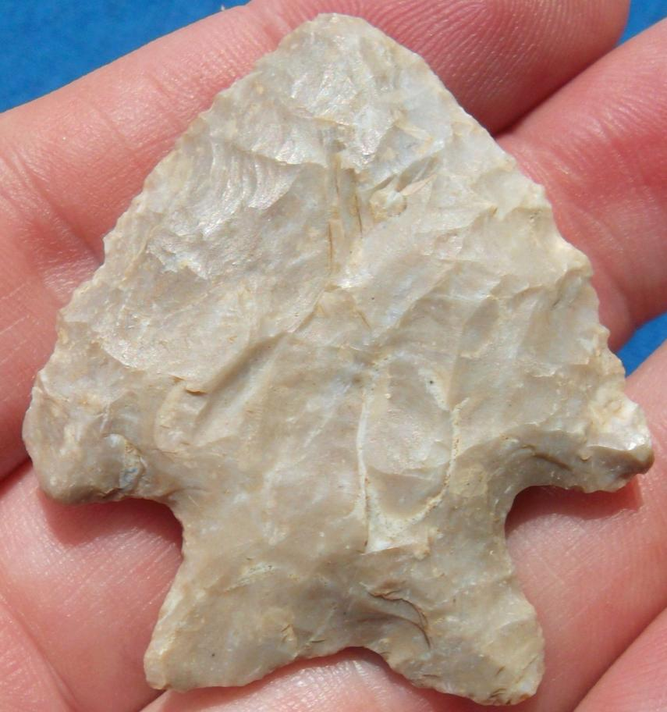

Our artifacts are guaranteed authentic and genuine without modern rework or restoration unless noted. Customer satisfaction is a priority. We offer a no questions asked 14 day money back guarantee if item(s) are returned in the same condition as listed.